NT1 Luke and Acts
Dr. Marvin J. Effa
Gospel of Luke

Author: Luke, an educated physician (Colossians 4:14), has been universally recognized as the author of both Luke and Acts. He includes his own eye-witness accounts and adds a medical vocabulary consistent with his training. He states that he used sources, but also had perfect understanding of everything written.

Date of writing: It seems that Luke wrote to the Gentiles during Paul’s two-year imprisonment in Caesarea. We also know he wrote Luke before Acts, so a date around 60 AD is appropriate (Acts 24:27).
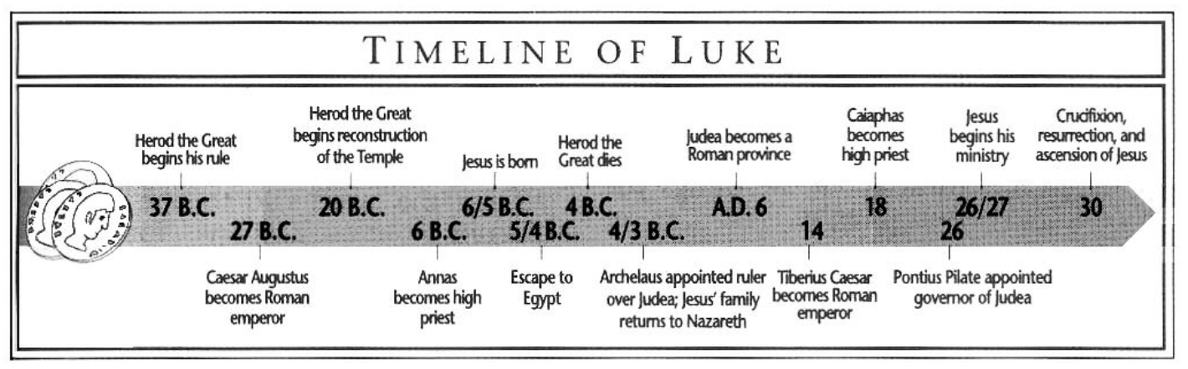

Purpose: To provide a chronological treatment of the life of Christ. Luke should have priority in historical placement of events in the Gospels.
Idea: The Gospel of Luke has a dual purpose: it first provides a chronological treatment of the life of Christ, to the end that a person has a solid foundation for faith in Him; it also provides proof to governing officials that Christianity is not a political threat. (Luke 1:1-4).

Development:
Luke: The history of the Son of Man.
- The beginnings and ministry of the Son of Man, 1-9:50.
- The rejection and crucifixion of the Son of Man, 9:51-23.
- The resurrection and appearances of the Son of Man, 24.

Key Passage Exegesis
- God’s love for the lost, Luke 15.
- The Pharisees love of money, Luke 16.
- The theme of Luke (Luke 19:10), and accountability in the Kingdom, Luke 19:1-27.

Acts of the Apostles

Author: Luke is accepted as the author. As Paul’s personal doctor, he traveled from time to time with the Apostle. The “we” sections of Acts (16:10–17; 20:5–21:18; 27:1–28:16) indicate Luke was with Paul.

Date of writing: If the Gospel of Luke was written during the Caesarean imprisonment, it seems likely that Acts was written during the first Roman incarceration. A date of 61 is appropriate because Paul came to Rome in 59 and had been there for two full years at the end of Acts. 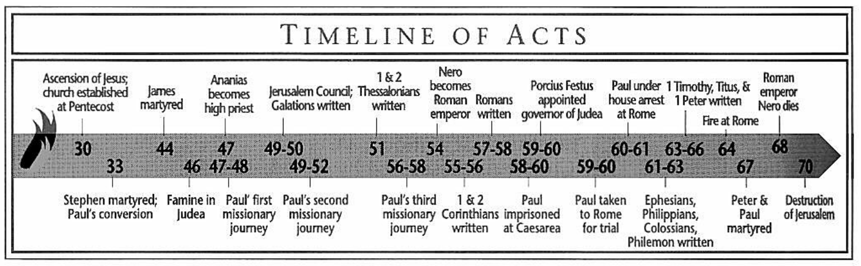

Purpose: To show what Christ meant when He said that He would build His church. Acts traces the Holy Spirit’s work in planting and establishing churches from Jerusalem to Rome.

Idea: The local church is God’s solution to the salvation, sanctification, and ultimate deliverance of Jews, Samaritans, and Gentiles.

Development:
Acts: The Planting and Establishing of the Church.
- Beginning in Jerusalem, 1-8.
- Israel and Syria, 8-12.
- Uttermost part of the World, 13-28.

Key Passage Exegesis
- The coming of the Spirit, Acts 2.
- Solving the church’s first crisis, Acts 6.
- The church’s first martyr, Acts 7.
- The Gospel to the Gentiles, Acts 10.
- The Jerusalem Council, Acts 15.
- The Ephesian Elders, Acts 20.
- The end of the beginning, Acts 28.

